McCann called the meeting to order with the following members present: Cole, Conway, Crick, Dunn, Emerson, Frazier, Gardner, Gonzalez, Hall, Kaipa, Kakani, Kazianga, Khojasteh, Liu, M. Lovern, P. Lovern, McCann, Melancon, Moss, Nelson, Neurohr, Pivateau, Rebek, Smith, Talley and Yates.
Also present: Bays, B., Beard, K., Buzzard, S., Cheves, T., Hallenbeck, D., Hargis, B., Masters, B., Miller, B., Moon, G., Peaster, R., Queen, A., Rigsby, S., Roberts, M., Robinson, M., Rodriguez, A., Sandefur, G., Schultz, A., Sewell, K., Sheehan, R., Smith, B., Wadoski, A., Weaver, J. and K. Wray.
Absent: Bindewald, DeSilva, McFarlane, Peek and Ware.

HIGHLIGHTS

Special Reports – Dr. Brenda Smith – SCORE………….……………………………………
Michael Robinson – OSU Public Safety Officer
Sgt. Adam Queen – OSU Police Department……………………………..
Remarks and Comments – President Hargis………………………..……………………..….
Report of Status of Faculty Council Recommendations and other Vice Presidents…….…….
Reports of Liaison Representatives …………………………………………………….……..
SGA…………………………………………………………………………………….
Emeriti…………………………………………………………………………………
Graduate Council………………………………………………………………………
Women’s Faculty Council……………………………………………………………..
Wellness Center ……………………………………………………………………….
Reports of Standing Committees ………………………………………………….…………..
Academic Standards and Policies ……………………………………….…………….
Athletics ………………………………………………………………….……………
Budget …………………………………………………………………….…………...
Campus Facilities, Safety and Security ………………………………….……………
Diversity………………………………………………………………….……………
Faculty ………………………………………………………………….……………..
Long-Range Planning and Information Technology ………………….………………
Research ……………………………………………………………….………………
Retirement and Fringe Benefits ……………………………………….………………
Rules and Procedures ………………………………………………….………………
Student Affairs and Learning Resources …………………………….………………..

McCann told those attending the meeting that she and Pam Lovern saw Dr. DeSilva today. He is looking better every time she sees him. His prognosis is very good. He’s still in a back brace but he is convinced he will be back for the December meeting, if not he will be back in January. McCann called the meeting to order and asked everyone present to sign the roll call as it is circulating the room and if you are a proxy for someone please sign your name as well as that of the council member whom you are representing. McCann entertained a motion to approve the minutes from the October meeting. Talley moved, Neurohr second. Motion passed. McCann entertained a motion to approve the agenda for today’s meeting. Rebek moved, Gardner second. Motion passed. McCann introduced Dr. Brenda Smith.

Special Reports:

- Dr. Brenda Smith – SCORE

Dr. Smith thanked the council for the opportunity to present the highlights from the SCORE report. She presented the following PowerPoint presentation to the council.



Smith would be happy to share the report with anyone who is interested in viewing it.

Smith opened the floor to questions. Melancon asked if there is any place for infra-structure? Smith stated that this was not a major thing. The survey was more around services than needing certain types of equipment/labs/etc. Smith said they asked what really inhibits or challenges your research productivity infrastructure was not the type of things they heard. Melancon said this may be an isolated issue based on the department.

Smith stated they will have a town hall meeting after the first of the year that everyone will be invited to attend. They hope to hold this after the first of the year and she hopes these conversations will continue.

- Michael Robinson – OSU Public Safety Officer
Sgt. Adam Queen – OSU Police Department

Robinson thanked the council members for the opportunity to speak at the meeting. Robinson addressed the recent “possible shots fired” incident at the Edmon Low Library. Robinson stated that on October 15th at 10:50 they received two calls from people who believed they heard gun fire coming from inside the library. Officers were dispatched and the first officer arrived at 10:51. This one minute response time was largely due to the establishment of a core campus patrol division. This division was started a few years ago. These officers are located in the Union, Library and various other buildings in the academic core area of campus during the classroom portion of the day. The first responders saw no signs of a disturbance. No one was running out of the building or hearing anything suspicious. Within two minutes there were six officers on the scene. So from a response standpoint things went as well as you could possibly hope for. Even with no signs of any disturbance, they followed protocol. Since the incident at Virginia Tech the protocol for officers have changed so that the first officer on the scene is going into the building and try to assess and eliminate any threats if they see one. Officers began to evacuate the library. They did a floor by floor search to make sure there were no problems or threats. It was determined that the noise that was heard was construction noise that was mistaken for gunfire. Could have been a hammer hitting concrete which Robinson feels could be mistaken for gunfire. Robinson stated that the following Monday they had a debriefing at the Emergency Management Center to use this incident as an opportunity to assess their response – what was done right, what needs to be improved and learn from it. Robinson stated that one thing they learned from the incident is there is a disconnect from the training they have been providing for years (on an as-requested basis) and what the perception most people feel they should do if such an incident was to occur. Robinson asked the council members if the proper response to an active shooter in a building is to “shelter in place and wait on the police to arrive”. No hands went up. Robinson was surprised because most of the people they asked, 100% said to “shelter in place”. This is not how they train but apparently it is the perception of a large number of people. Robinson stated this is an area they need to address.

Robinson told the council members that the biggest killer in this country is heart disease. Robinson stated that there are 610,000 deaths from heart disease annually in this country. You are 13,000 times more likely die from a heart attack than at the hands of an active shooter. Robinson said there are 32,000 deaths and 2 million injuries annually as a result of automobile crashes. You are 681 times as likely to die in an automobile crash as at the hands of an active shooter. There are 3,500 deaths annually and 390,000 injuries due to texting while driving. So are 74 times more likely to die as a result of someone texting while driving than at the hands of an active shooter. None of these things elicit the emotional response that an active shooter situation does. News coverage is one of the many reasons for this. Robinson said people are not worried about being struck and killed by lightning. If we are at Boone Pickens Stadium and detect lightning within an eight mile radius, the event is shutdown. We still take reasonable precautions when a threat exists, so we should approach an active shooter situation in the same way. Even though it is extremely unlikely that it will happen, it only makes sense to train to the degree we can.

Robinson gave the following facts to the council members: From 2000-2013 there were 160 incidents:
- 15% of these ended in under 2 minutes.
- 60% (the majority) were over in less than 5 minutes.
- 60% ended before law enforcement arrived on the scene. This should tell you something about “sheltering in place.” In over 50% of the cases, the incident was over before the police ever arrived.

This tells us that it is incumbent upon everyone to know how to react in this situation. There is a very reasonable chance the incident will be over before police arrive. Robinson asked how many rounds can be fired in a minute? Given time to reload, Robinson estimated a minimum of 60 rounds. A minute is a long time when someone is firing an automatic weapon. After studying these incidents, the FBI found that even after law enforcement arrived, many times civilians have to make life and death decisions regarding their own safety even with a police presence. Robinson stated that they are planning some trainings to be held in the Student Union Theater. Some tailored to faculty, some to staff and others to students. Robinson asked how many people would attend a training session? About 60% raised their hands. Robinson asked if 2 hours was too long for the training? Was an hour more reasonable? Most stated 1 hour was better. Robinson asked how many believe this type of training should be mandatory for faculty and staff? No one wanted it to be mandatory.

Robinson turned the floor over to Sgt. Queen who presented the following PowerPoint regarding the Active Shooter training the OSU Police Department provides.

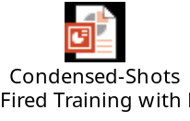

Queen opened the floor to questions. Hall asked for the name of the new app which is replacing the Orange Shield app. Queen stated the app is called Rave Guardian. Conway stated he did not see an emergency number on the app, only non-emergency. Queen stated that is correct, because with new technology we now need everyone to do just a normal 911 call. Now with the new 911 system, if dialed from a cell phone, they know where you are located. It’s very accurate according to Sgt. Queen. Masters noticed when the app was downloaded it is recommended that you have your location always on. Masters asked what will be happening to all this data? Queen stated that the information that is entered into the account is only viewable by the OSU Police communications officers. It won’t be sold or given to anyone. Masters asked if Guardian collects data on everyone using the app? Queen does not believe so. Queen said for example: the medical information that is provided can alert officers to a specific medical need when they respond to a medical call. Masters is more concerned with tracking data on the app. Queen stated that the location services are used when someone texts or calls in, so the police can find where you are. Queen stated that there is a function on the app called “safety timer” which can be set up to track the travel of a person/student. This can be helpful to parents when a student is driving home. Masters stated that there is a real concern about location data on apps.

Gonzales asked what the data could provide in terms of the 911 calls (referencing the recent incident at the library) since just two people called. Queen stated that of the two calls, one was a student and he believes the other was the parent of the student. This has not been confirmed. Robinson stated in hindsight, if this had been an actual incident, they would have received 20 times that number of calls very quickly. Queen stated that if you understand what gun shots sound like in a building, it is not like what you hear in movies and on tv. In the training session they have actual gun shoots (they use blanks) so people will recognize what they sound like. Because of so many things that absorb sound, gun shots in a building sound very different. Queen would rather have people call and report something that turns out to be nothing than not report something that could turn out to be something.

Remarks and Comments – President Hargis:

Hargis said there are a lot of performances going on at the McKnight Center and encouraged all faculty members to attend a performance. Many performances are by the OSU music school that are free and parking is free.

Hargis stated that the opening of the McKnight Center by the New York Philharmonic was fantastic. They raved about the acoustics in the hall. This is a pretty big deal.

Hargis stated that Celia Sandys, Churchill’s granddaughter, was on campus speaking. It was a great event.

Hargis asked Kyle Wray to give an update on applications. Wray stated that numbers are up significantly - in excess of 2,000 applications compared to this date last year, and in excess of 500 admits since this date last year. People are asking why these numbers are up and Wray stated that communication efforts are hitting on all cylinders. We get smarter every year in terms of data analytics. Wray stated that we learn what students respond best to – text, mail, email, personal visit, etc. Wray stated that December 1st their attention will turn to three events that promote getting students of high talent (27 or higher on the ACT). They will be at: the McKnight Center for the Performing Arts, the Philbrook Museum in Tulsa and at the OKC Museum of Art. These have proven successful over the past few years. As a result of these events, the OSU Honors College is busting at the seams.

Hargis stated that Governor Stitt will be our commencement speaker. We are awarding 3 honorary degrees during the commencement ceremonies.

Report of Status of Council Recommendations:
Provost Sandefur and Vice Presidents

Dr. Sandefur gave the Council members an update on recommendations.

The following recommendations remain pending:

18-05-02-Faculty: Proposed changes to the Preface and Body of the “Policy Statement to
Govern Appointments, Tenure, Promotions, and Related Matters of the Faculty of OSU”
19-08-01-Research: Revisions to OSU P&P 4-0125 Complaints of Research Misconduct

Report of Liaison Representatives:

- SGA – Ashely Schultz

SGA College Elections Next Week
Increasing Social Media for SGA to reach more of the student body

- Emeriti Association – Barbara Miller

Baseball Coach Josh Halliday was the guest speaker at our November Dinner. He spoke about progress on the new stadium, the state-of-the-art systems being added, and showed schematics on the seats which will be available for purchase as individual or season tickets.

The December Emeriti Dinner will be held December 9. The May dinner will be in conjunction with the Olli group at Meditations. Entertainment will be the Stillwater High School Choir. The making the Most of Retirement group will visit the Poinsettia house on campus.

A review is underway of the Emeriti group constitution and bylaws.

November tours included a trip to the National Weather Center on November 7. More tours are planned for spring.

- Graduate Council – Rebecca Sheehan

Academic Program Committee. A variety of degree modifications were approved.

Slate Operations. Dr. Brenda Smith reported that Slate is now up and fully functioning for both domestic and international applications. Julie Cunningham, manager of the Graduate Admissions Process, is continuing to host training sessions for groups.

Summer Research Writing Course. In response to student feedback, the Summer Research Writing Course conducted by Dr. Steph Link will now be 10 week course in the summer rather than the original 8 week format.

360⁰ Critical Skills. 360 is OSU’s graduate student professional development program that includes communication, instruction, research, management, leadership and wellness dimensions. Dr. Smith gave an update that 360⁰ participation this fall exceeds participation for all of last year.

Requirement for Advisor Voting in the Affirmative. Council endorsed removing the requirement that the advisor must vote in the affirmative for a passing thesis or dissertation defense. The Council will vote on this measure after receiving feedback from the Graduate Faculty Subject Matter Group Meetings.

Graduate Faculty Training. A Graduate Faculty Professional Development/Training working group from Graduate Council, representing all groups, is developing a needs assessment survey for all new and existing graduate faculty at OSU. The survey will take place in spring 2020, and all graduate faculty are encouraged to complete it. This survey will inform how training will be developed for graduate faculty.

Dual MS. Dean Tucker explained that graduate programs with a specific population of well-qualified students, typically those with extensive career experience, are creating opportunities for dual master’s degrees. This is somewhat analogous to 4+1 programs. For example, the MS in Health Care Administration and the MBA programs have designed a curriculum that shares 15 hours and leads to the completion of both master’s degrees simultaneously.

- Women’s Faculty Council – Awilda Rodriguez Carrion

We received a good turnout of applications for our inaugural Women’s Faculty Council Outstanding Achievement Awards. While all of the candidates nominated were deserving, we have selected three awardees to honor for their accomplishments in research, scholarship, and mentorship. The three awardees will be formally announced at the University Convocation on December 11th at 3 pm.

The speaker for the November WFC meeting was Dr. Melanie Wilcox, Assistant Professor and Director of Counseling Psychology, who spoke on ‘Understanding the Lives of Lower Socioeconomic Status Students in Higher Education’. Dr. Wilcox touched on the financial difficulties many students experience, and the effect of these difficulties on their education, University success, and overall well-being. She encourages faculty to foster positive relationships with students and encourage them to reach out for assistance, look for warning signs, familiarize themselves with campus and community resources, and to be an advocate for students who are struggling.

Upcoming meetings and events:

- December WFC meeting on December 4th, 4-6 pm, Iron Monk Brewing Company
o This event is a come-and-go social event for all interested participants to meet other faculty and connect in a casual environment
- Due to unforeseen circumstances, the anticipated January seminar by Sanaa El-Sayed has been canceled. Stay tuned for further information about the January meeting.

Anyone interested in the WFC can visit our website at womensfacultycouncil.okstate.edu and sign up to be put on our email list.

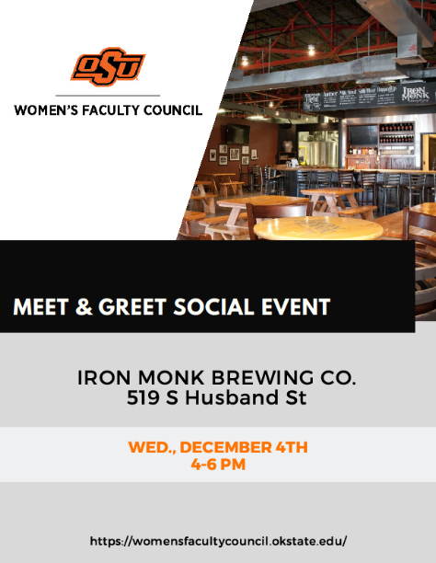
- Wellness Center – Kim Beard
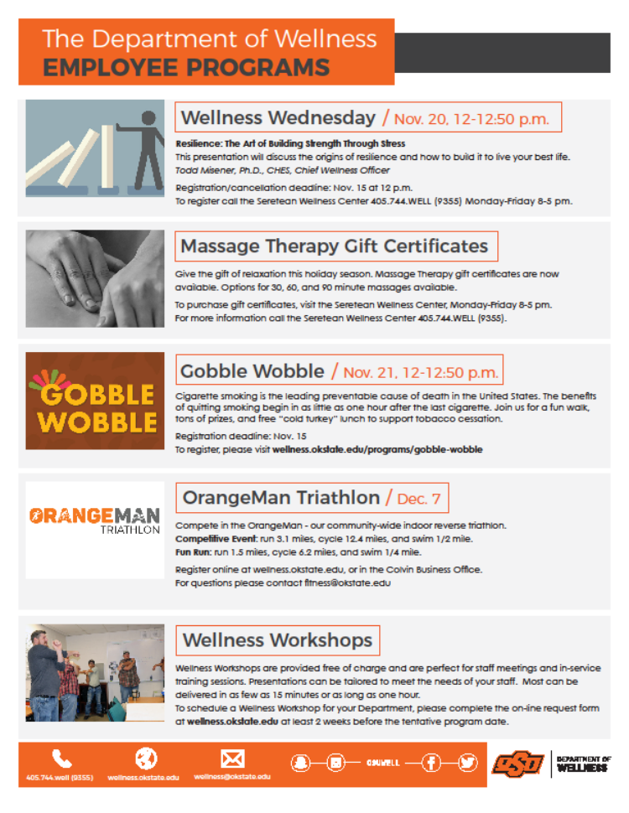
REPORTS OF STANDING COMMITTEES:
- Academic Standards and Policies: Eric Rebek – Update
Rebek stated that the committee agreed with the small wording changes, made by Registrar Peaster, to the recommendation that was provided with the agenda. McCann asked for discussion and questions. Seeing none, moved to a vote. Motion passed.
- Athletics: Justin Talley – No Report
- Budget: Jam Khojasteh – No Report
- Campus Facilities, Safety, and Security: Karen Neurohr – Update

The Campus Facilities, Safety and Security (CFSS) Committee met on October 29. Guest speakers were Vice President Joe Weaver, Deputy General Counsel Scott Fern, and Vice President Doug Hallenbeck. Fern and Weaver provided information regarding the OAMC Board of Regents Policy 3.09 “Weapons, Firearms, Ammunition, Fireworks, and Explosives and Dangerous Chemicals.” Extensive work went into this policy, and the Regents approved it last year.

Hallenbeck provided information from the Students of Concern Committee (SOC) and the Behavioral Consultation Team (BCT). He also shared information about the numerous campus resources provided by the University Counseling Services. Mike Buchert, CFSS Committee Member and Director of Long Range Facilities Planning, provided information about Current and Future Facilities Projects.
On Nov. 21 at 2:30 p.m., the CFSS Committee will meet at the OSU Emergency Operations Center for a tour. Any Faculty Council members are welcome to join us for this meeting. Following the tour, the Committee will meet. Please let Karen Neurohr know if you want to participate, and she will send further details.
- Diversity: Justin Moss – No Report
- Faculty: Matt Lovern – No Report
- Long-Range Planning and Information Technology: Christopher Crick – No
Report
- Research: Dianne McFarlane – No Report
- Retirement & Fringe Benefits: Griffin Pivateau – No Report
- Rules and Procedures: Pamela Lovern – No Report
- Student Affairs and Learning Resources: Toby Nelson – No Report

Old Business – None
New Business – Executive Committee Recommendation and Resolution

Lovern stated that there is one recommendation and one resolution that were provided with the agenda. These are bookkeeping/administrative issues that are related to the upcoming reaccreditation of OSU by the Higher Learning Commission (HLC). We have asked Dr. Brenda Masters to explain these two items.

Masters said the resolution is to demonstrate continued commitment to the OSU Strategic Plan. Masters explained that what we refer to as our strategic plan is the mission, vision, core values and core goals. This set of documents is very important to our accreditation and our midterm review that will be in the spring. One of the items we have to provide evidence for is that there is “current” support for the plan. Our mission, which we refer to as the strategic plan, was passed by the A&M Board April 24, 2015 so by the time we have our review next spring it will be more than a half decade. We are requesting that all levels of the governances beginning with Faculty Governance as well as the deans and executive teams to voice a resolution of “continued strong commitment to the strategic plan”. As we bring this forward, it is for Faculty Council to review the strategic plan and mission. This speaks to the heart of who we are, what we want to be and how we expect to achieve it. McCann asked for discussion and questions regarding the resolution presented today. McCann asked for a motion since the resolution did not come from a standing committee. Neurohr moved, Crick second. Motion passed.

Masters explained the recommendation that was also provided with the agenda. This recommendation is for OSU to not have three or more of what the HLC refers to as “additional locations.” Masters clarified the term as follows: OSU has two branch campuses (OSU Center for Health Sciences and OSU Tulsa). OSU has two constituency agencies that are associated with us in our system (OSU-IT and OSU-OKC). These are often confused as branch campuses. Masters stated that branch campuses are ones where we have responsibility for their accreditation (OSU Center for Health Sciences Center and OSU Tulsa). Our constituency agencies are universities that work with us and hold their own official accreditation. In addition to this, OSU can also have what is referred to as “additional teaching locations.” We do have two currently, one of them being OSU-OKC because we teach more than half of the course work for specific degrees at that location. When this occurs, we are then responsible for that location in terms of the crime statistics, accreditation information, etc. When we have more than 2 additional locations, we may then be required have site visits. This question arose two years ago when we added the new Cherokee Nation Hospital (which is still under construction) in Tahlequah. This will be a branch of OSU Center for Health Sciences. When we added the hospital in Tahlequah two years ago, this caused us to have three “additional locations.” The third one is a fire station in Korea. Some people may not be aware that OSU was involved in training Korean firemen for the national Korean fire service, but we have been for more than a quarter century. The HLC contacted us two years ago letting us know that with three locations, the HLC will now do site visits at two of the three. One of the locations chosen was the Korean location. The site visit team would only be there for 4 hours and the cost would be paid for by OSU. Masters began to contemplate if there is a real advantage for OSU to be able to teach classes that make up more than half the course work in any specific degree at a different specific location. Masters stated this does not include online courses. If you transmit a video class to a specific location, that’s the same thing as being in person. In today’s world, with online access, it is not worth the financial cost each year to have an additional location and the accreditation liability on universities for which we do not have administrative control. This is a very dangerous proposition with accreditation. So we recommend that OSU never has more than the two additional locations we currently have – OSU-OKC and the new Tahlequah hospital. There is not a current policy that addresses this issue. As such, faculty members could decide as a group that they would interact with a university which might create “additional locations” that will be a financial burden to the university. The federal money that goes to students at these additional locations in the form of student loans is our responsibility. OSU would be liable for all these student loans and any other financial aid that the university incurs on our behalf. This recommendation is a matter of caution.

McCann asked for questions and discussion. Seeing none asked for a motion. Rebek moved and Conway second. Motion passed.

The meeting adjourned at 4:10 p.m. The next regular meeting of the Faculty Council is Tuesday, December 10, 2019 at 3:00 p.m. in the Council Room, 412 Student Union.

Respectfully submitted,
Pamela Lovern, Secretary

