DeSilva called the meeting to order with the following members present: Champlin, Ellis, Emerson, Frazier, Kaipa, Kakani, Khojasteh, Lovern, McCann, McFarlane, Moss, Nabar, Nelson, Neurohr, Peek, Ramsey, Rebek, Talley, Wanger and Holtzhower for Yates.
Also present: Atiyeh, H., Clark, G., Cole, K., Conway, T., Dunn, B., Gonzalez, C., Hall, S., Hallenbeck, D., Kazianga, H., Lovern, M., Miller, B., Parli, R., Peaster, R., Quay, T., Roberts, M., Sandefur, G., Sewell, K., Stokes, P., Underwood, D. and Weaver, J.
Absent: Bindewald, Crick, Hurst, Jones, Kak, Melancon, Piehl, Pivateau, Sheehan and Ware.

HIGHLIGHTS

Special Reports – Dawn Underwood, Assistant VP for Research Compliance………………
Ramesh Kaipa, OSU Speech-Language-Hearing Clinic…………………..
Remarks and Comments – Provost Sandefur for President Hargis……………………..…….
Report of Status of Faculty Council Recommendations and other Vice Presidents…….…….
Reports of Liaison Representatives …………………………………………………….……..
Emeriti ………………………………………………………………………………..
Staff Advisory Council………………………………………………………………..
Wellness Center ………………………………………………………………………
Women’s Faculty Council……………………………………………………………..
Graduate Council ……………………………………………………………………..
Reports of Standing Committees ………………………………………………….…………..
Athletics ………………………………………………………………….……………
Budget …………………………………………………………………….…………...
Campus Facilities, Safety and Security ………………………………….……………
Diversity………………………………………………………………….……………
Faculty ………………………………………………………………….……………..
Long-Range Planning and Information Technology ………………….………………
Research ……………………………………………………………….………………
Retirement and Fringe Benefits ……………………………………….………………
Rules and Procedures ………………………………………………….………………
Student Affairs and Learning Resources …………………………….………………..
Academic Standards and Policies ……………………………………….…………….

DeSilva called the meeting to order and asked everyone present to sign the roll call as it is circulating the room and if you are a proxy for someone please sign your name as well as that of the council member whom you are representing. DeSilva let the members know that there was a slight change to the agenda. Provost Sandefur will be presenting the remarks for President Hargis who is at a meeting this afternoon. DeSilva entertained a motion to approve the revised agenda for today’s meeting. Ramsey moved, McCann second. Motion passed. DeSilva entertained a motion to approve the minutes from the April meeting. Neurohr moved, Rebek second. Motion passed. DeSilva introduced Dawn Underwood, Assistant VP for Research Compliance.

Special Reports –
- Dawn Underwood – Assistant VP for Research Compliance:
Underwood introduced herself and distributed the following handouts and presented a PowerPoint presentation:
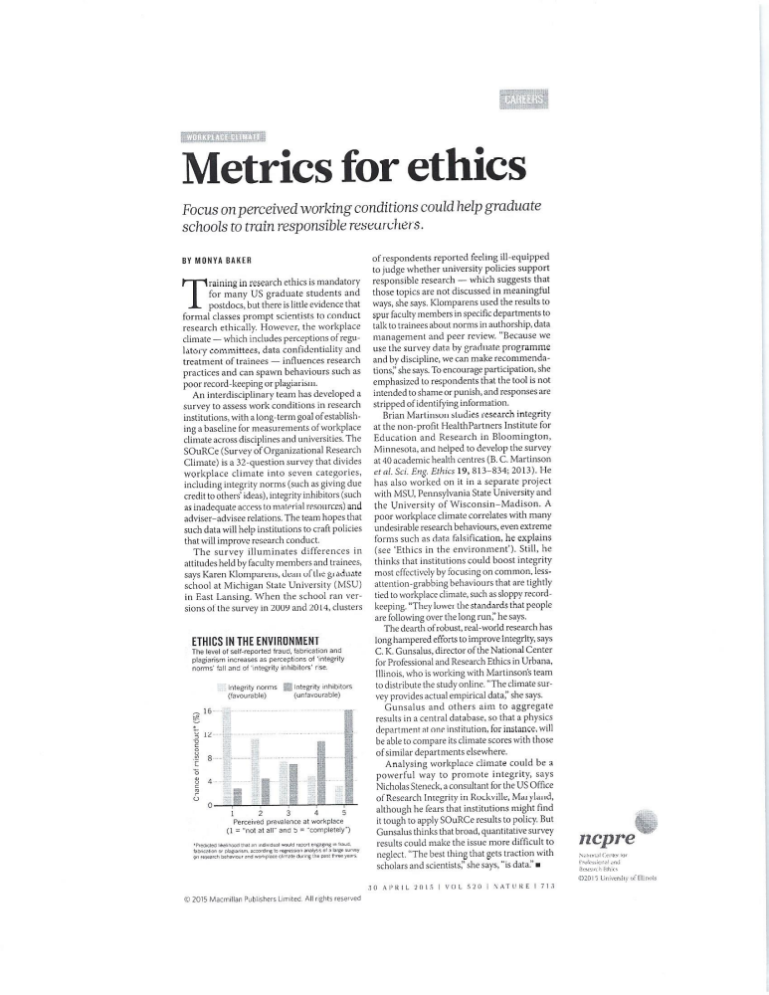
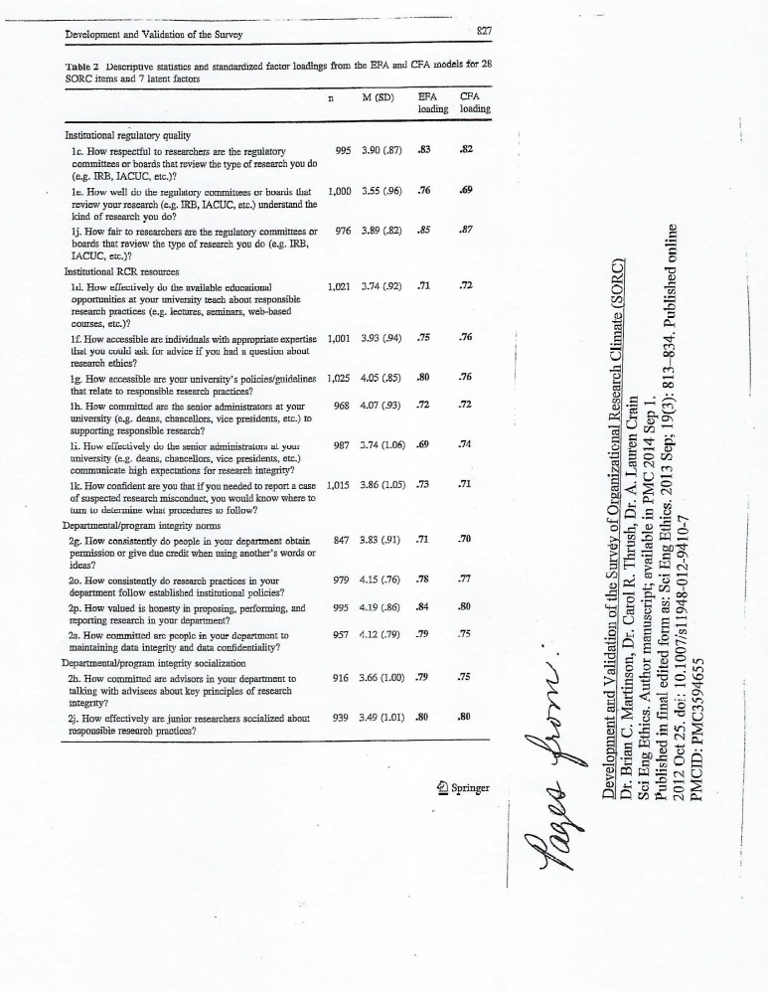
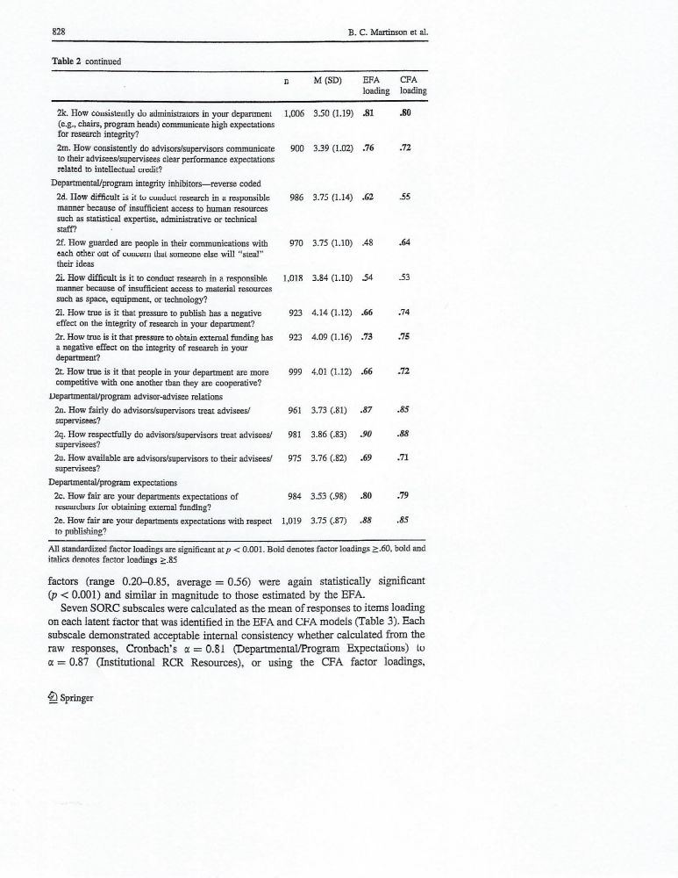


Underwood opened the floor to questions. Khojasteh commented that confidentiality (regarding survey responses) usually isn’t an issue but if you have a department with 5 people based on demographic information you will be able to determine who each person is. Underwood stated that they would exclude any particular demographic parameters for smaller departments. DeSilva asked how the feedback is provided to the departments? Underwood stated that the departments give them access to their database systems that shows standard reports with the grids, bar charts and ratio tables. Underwood said this information is shown to them for ‘x’ amount of days to allow her group to pull the reports. Departments may also provide a spreadsheet of the raw data for OSU.

- Ramesh Kaipa – OSU Speech-Language-Hearing Clinic

Dr. Kaipa introduced himself and presented the following PowerPoint presentation as well as the following handout.

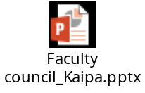
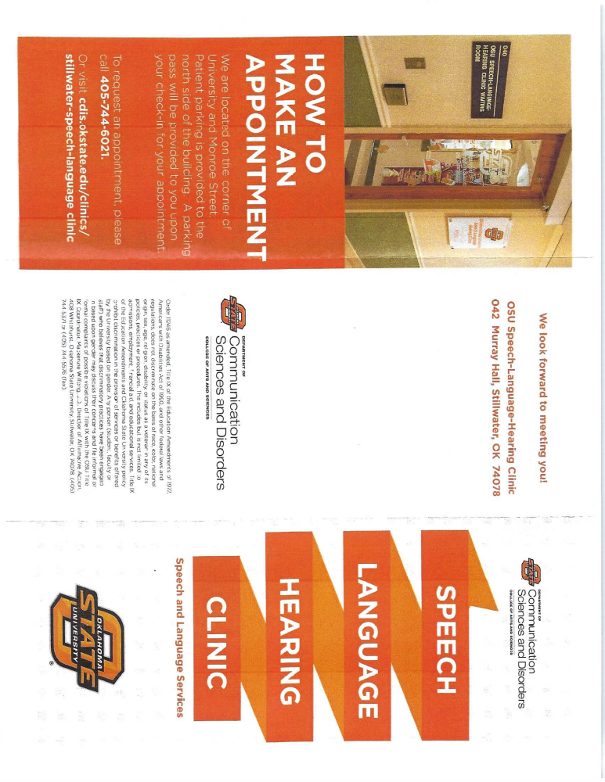
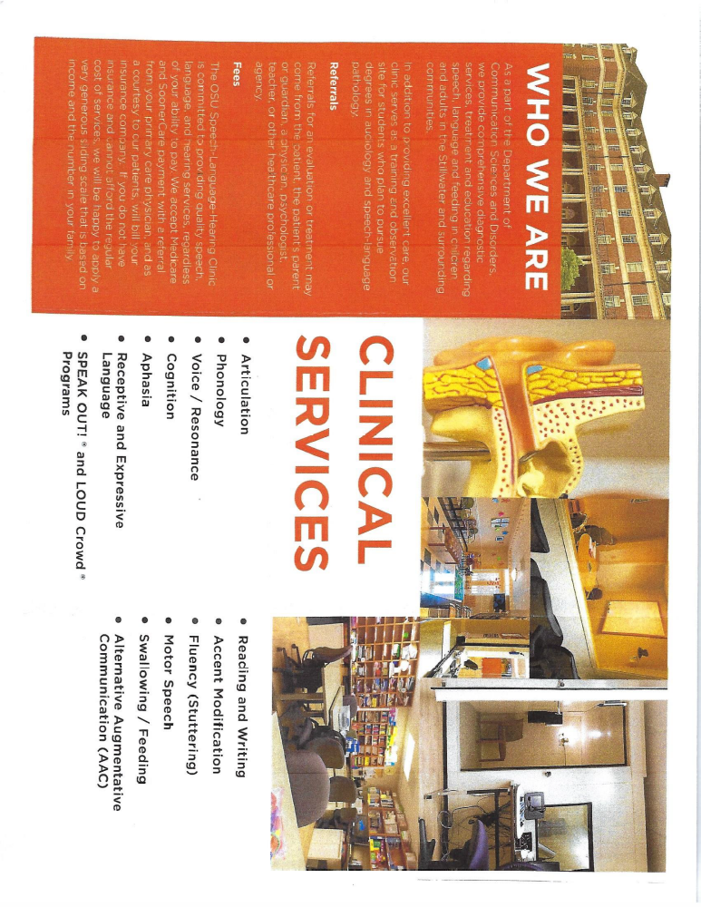
Kaipa stated that he is seeking the council members assistance and trying to partner with the Outreach Office and hopefully the Wellness Center to get the word out that the clinic exists and is here to help people. Kaipa opened the floor to questions. Miller asked if children of OSU faculty and/or staff members are covered under OSU’s insurance. Kaipa stated that they offer very subsidized discount rates.

Remarks and Comments – Provost Sandefur for President Hargis:

Provost Sandefur shared the following information from the President’s office:

Commencement: 4,500 graduated in the spring semester. Approximately 3,500 attended
the ceremonies.
Reappointment, Promotion and Tenure season. The Provost reviewed 114+ cases.
Cuts in state support: OSU has kept tuition and fees below the regional average
through development growth, cost savings, outsourcing, modernization and fundraising. We are working hard on next fall’s entering class. Things are looking pretty good right now.
Retention: working hard to keep students at OSU after their freshman year.
Finish in 4: while we want to keep students in school, we are pushing for them to finish
in 4 and get out as soon as they can. So our 4-year and 5-year graduation rates went up last year. We had more students graduate, which cuts into the university’s revenue, but it’s a good thing.
New Facilities:
Endeavor Lab
McKnight Center – Opening this fall. The New York Philharmonic will perform.
Greenwood School of Music – Beginning construction.
Business Building has been up and running for more than a year now. Students
and faculty love it.
Next on the list of academic projects:
Ag – Ag brings in students from across the country. We have top tier programs in
Animal and Food Science. The judging teams do an amazing job. Equine, Meats and Livestock all won national titles in the same year. The “New Frontiers Campaign” has begun to raise money for the new Ag Hall which will be coming soon.
Sandefur stated that we are excited to have three students win the prestigious Barry
Goldwater Scholarship this spring: Christopher Jones from Edmond, Jeffery Krall from Mission Viejo, CA and Cole Replogle from Broken Arrow. To get one Goldwater Scholar in a year is a good thing, but three is an extraordinary accomplishment.
New student convocation and new faculty orientation will be in the fall. Planning
activities for these events will take place over the course of the summer. DeSilva said there has been some talk that this year’s convocation may somehow be different from previous years. Sandefur stated that there have been some discussions and input from various faculty members. The President and Provost do not want to change the faculty presence at the convocation. They feel this is very meaningful to the students. There has been discussion about making it more like a “pep rally” but they’re not sure yet where it will go. Sandefur stated you want the seriousness of “you’re beginning your college career” but you want to make it as fun and enjoyable for people as possible. Every year there is discussion about how it can be tweaked, but he does not believe it will change that much.

Report of Status of Council Recommendations:
Provost Sandefur and Vice Presidents

Dr. Sandefur gave the Council members an update on recommendations.

The following recommendation has been approved:

18-10-01-Exec : Procedures for Consideration of Removing Names of Facilities.

The following recommendation has been adopted in principle:

19-03-01-LRPIT: Support for One Classroom Response (“Clicker”) System.

The following recommendation remains pending:

18-05-02-Faculty: Proposed changes to the Preface and Body of the “Policy Statement to
Govern Appointments, Tenure, Promotions, and Related Matters of the Faculty of OSU”.

Dr. Doug Hallenbeck: VP Student Affairs

Hallenbeck addressed the council regarding measles outbreaks that have been in the news lately. Hallenbeck stated that there are approximately 860 measles cases nationally. Last couple of years, OSU has had 400 cases of the flu. In comparison, it’s still a relatively small number of cases. Hallenbeck stated that OSU does require students be immunized. 97% of the OSU students have been immunized. There are some exceptions by state law. Hallenbeck feels very confident that the work OSU is doing in conjunction with the state and county health departments means that quick action will be taken if an outbreak is possible. There are plans in place to handle the situation. Hallenbeck does not anticipate any issues with the student population since they are required to be immunized. His office is more concerned with those who were born from 1960-1989. This population would have received only one dose of the MMR vaccine. It is possible this group may need a booster shot. Hallenbeck stated that the booster shot is covered by BC/BS. University Health Services will provide the booster to those who wish to get one. If you do not know if you need a booster, just ask them and they will help you through the process. Hallenbeck stated that they have been working on an announcement that should go out over the summer to faculty and staff. Pam Stokes is attending the meeting and would be happy to answer any questions regarding immunizations. Peek asked how people would know if they are ok or if they would need a booster. Stoke stated that people could dig back into their records and try to find the information. Stoke stated that most people born between 1960 and 1989 most likely only had one vaccination. If you have a question, stop by Health Services where they can draw a blood titer and check everything for you. Stokes stated that it is cheaper to get the booster shot than to do the blood draw and titer. However, they would be willing to do whichever one the staff/faculty member wishes to do. Stokes stated that there is no harm in getting the booster if you are not sure. DeSilva asked how quickly you can get the shot? Stokes said they have it available right now. Stokes said to call 744-CARE (the faculty/staff line) if you would like to schedule an appointment or walk-ins are also welcome. Sandefur asked if you think you had the measles as a child but are not 100% sure, should you get the booster? Stokes said that for those born before 1957, she has been told that you most likely have some sort of immunity, so they consider that you are immune to measles. Stokes said that if you have any doubt whatsoever about whether you may be susceptible to measles, they do have a type of booster for these individuals. So it would not hurt you to get the shot.

Dr. Kenneth Sewell: VP Research

Sewell stated that as the semester comes to a close, many may have heard about the Tier 1 Initiatives that they have been working on for the last year or so. The groups are moving forward with applications for this process which are due the first of July for phase 1.

Sewell said they will be discussing in the coming weeks about their partnership with “The Conversation”. This program is now active and they are partnering with various communication professionals in colleges as well as the Research and Communications offices. They are currently receiving requests. Sewell stated that if anyone has an idea particularly related to current events that connects to a faculty member’s research expertise, please contact the research office if you would like to pitch this as a story for “The Conversation”. It’s not a big process. You would write a 700-800 word article from the perspective of your research expertise to address a particular issue related to some type of world event. Sewell stated they would like to have some type of event about “The Conversation” in the fall.

Sewell just returned from several meetings with the University Space Research Association and there are a lot of things going on with NASA and space exploration. Space exploration brought us more than just getting us to the moon, it generated unprecedented technological development as well as the excitement of math, science, exploration, and discovery. Sewell believes that reprioritizing space travel/exploration would benefit OSU through a lot of opportunities as a research university to both capture and elevate our research. He hopes to be speaking to the council about this more in the future.

Joe Weaver: VP Finance

Weaver stated that as far as the State Capital and the budget is concerned everyone is really mad at each other right now. There was a big blow up on Monday. This usually means we are close to a deal. Weaver anticipates the potential of higher education getting a little money. And we appreciate every dollar we get. At least it’s not a cut.

Report of Liaison Representatives:

- Emeriti – Barbara Miller

The results of the survey of University retirees are in. The Board was delighted to learn that over 40 percent turned in their survey! Copies of the full report will be sent to President Hargis and Provost Sandefur, with copies to Joe Weaver and the University Deans. The entire document will be available on the Emeriti website. Highlights include a high involvement in University activities, with nearly 70% continuing to purchase tickets to theatre, music and arts events, and nearly 60% purchasing tickets to sporting events. Over 60% donate to department, college and university scholarship programs and to University fundraising campaigns. In addition, over half of respondents continue to serve on university committees, serve as mentors, and usher at OSU events. Over 80% of respondents said they had children and grandchildren who attend OSU.

We hope the results of the survey will be helpful to the University Administration in planning future activities at OSU.

- Staff Advisory Council – Raquelle Parli

- Staff Advisory Council just completed our election process for Council positions for 2019-2020. All ten available positions were filled (7 with returning incumbents and 3 with new members). Newly elected and returning incumbents will be seated at our June End of Year luncheon and training meeting. Council officers for 2019-2020 will also be elected at that meeting.

- One of Staff Advisory Council’s big events of the year is coming up on Wednesday, May 22 and that is our annual Staff Celebration Day. This event runs from 11:00-1:00 and is a come and go free lunch for all OSU staff members. Food this year will be catered by Rib Crib. Staff Celebration Day is sponsored by SAC and is provided by the OSU Administration as a thank you to staff members. Please encourage the staff members in your areas to attend the event! We ask you to be flexible in allowing staff members to take additional time for lunch on that day if at all possible so that they can enjoy the food and vendors.

- Wellness – Kim Beard
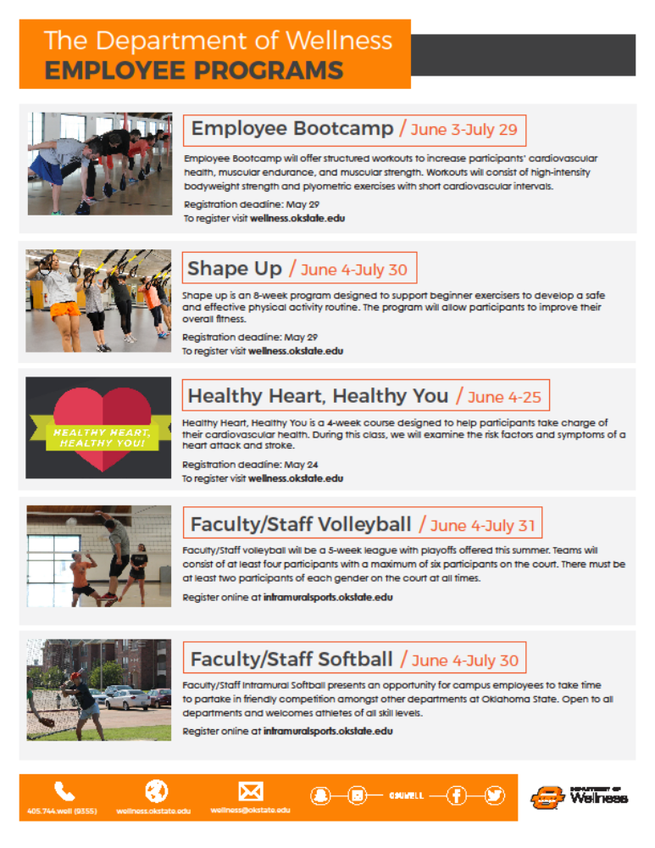

- Women’s Faculty Council – Tracy Quan

The WFC would like to thank everyone who attended any of our meetings, book clubs, and seminars, as well as the many faculty who reviewed the applications for research awards and the Ann Ryder and Clara Smith Leadership Scholarship. We have really appreciated all the assistance, input, and support!

Other highlights from this year include:

- Inviting 6 guest speakers from OSU to discuss critical issues surrounding our campuses
- Hosting Dr. Rebecca Sandefur who presented during Research Week on The Quiet Crisis of Access to Justice
- Offering a Preparing Future Faculty Panel with representatives from across academic ranks at OSU
- Discussing the book Lived Experiences of Women in Academia with facilitator Erica Townsend
- Awarding $17,000 in scholarship and award funding to 23 undergraduate and graduate students across OSU colleges
- Initiating the first annual Faculty Poster Symposium
- Receiving funding from the President’s Fellows Fund to offer three new WFC Faculty Awards at $1500 each. Stay tuned for more information in the fall!

The incoming WFC Chair is Dr. Kim Loeffert, and she is very interested in suggestions for activities and speakers for next year. Dr. Awilda Rodriguez Carrion will be the new liaison to Faculty Council. Elections for next year’s WFC Vice Chair, Secretary, and Treasurer are going on now. If you are a member of WFC and have not received a link to the ballot/survey, please contact Steph Link (steph.link@okstate.edu).

Anyone interested in the WFC can visit our website at womensfacultycouncil.okstate.edu and sign up to be put on our email list.

- Graduate Council – Jon Ramsey for Rebecca Sheehan

Academic Program Committee. A variety of degree modifications and graduate certificates were approved.

Advisor role on the student advisory committee. The current policy states a successful defense must have the advisor approve, which potentially undermines the role of advisory committee. General Counsel will speak about policy at the next Graduate Council.

Vice Chair Election. Dean Tucker requested nominations from each of the six subject matter groups to serve on the Vice Chair Nominating Committee. As per the Graduate Council bylaws:

4.4.1. Only Full Members who have been employed full-time by Oklahoma State University for three academic years, and who have served at least one, two-year term on the Graduate Council, may hold the office of Vice-Chair.

It is expected that the Election Committee will provide a slate for endorsement at the May 17 meeting at 1:30 pm.

Membership Committee Report. Dr. Van Delinder presented nominations for Graduate Faculty Membership from the six subject matter groups. The Membership Committee reviewed the membership actions and voted.

Minimum Number of Dissertation Hours for the Ph.D. Dean Tucker and the Graduate Council will review best practices for the minimum number for the Ph.D.

Online Video Training for Graduate Faculty. Dean Tucker asked Council to consider if online video training modules would help supplement other types of training. Council agreed that such training would be beneficial.

REPORTS OF STANDING COMMITTEES:

Reports of Standing Committees:
- Athletics: Justin Talley – Year End Report

Athletics Committee: Justin Talley – Year End Report
Year-end Report 2018-19
ATHLETICS COMMITTEE
May 8, 2018

Faculty Council members: Justin Talley (Chair, Entomology and Plant Pathology), Dianne McFarlane (Veterinary Medicine Physiological Sciences, Faculty Council), and Aaron Ware (School of Culinary Arts, OSU-Institute of Technology – Faculty Council)
Members: Matt Upson (Library), Tom Royer (Entomology and Plant Pathology), Marilyn Middlebrook (Associate Athletics Director, Academic Affairs), Tim Snider (Veterinary Pathobiology), Kevin Fite (Senior Associate Athletic Director) and Stephen Clarke (Big 12 Faculty Athletics Representative)

Ongoing effort:
- The Athletics Committee met several times throughout the year to address the OSU policy 2-0217 regarding Attendance Policy for Students. The main issue was to refine the policy to define an excused absence so both student and faculty have equal representation addressing students who have an excused absence for university sponsored activities. The Athletics Committee modified policy 2-0217 and then sent it on to the Academic Policies and Procedures Committee which is currently addressing our modifications.

Other activities:
1. The committee also discussed policies related to large scale athletic events that disrupt normal university activities during the week and it was determined that these happen in such low frequency that no further action was warranted.

- Budget: Steve Wanger – Year End Report

Budget Committee
Faculty Council
2018 – 2019 Year End Report

Committee Members: Stephen P. Wanger (Chair), Toby Nelson (Faculty Council Member), Jam Khojasteh (Faculty Council Member), Sandeep Nabar (Faculty Council Member), Tyrrell Conway (General Faculty Member), Dingbo Lin (General Faculty Member), Rob Agnew (General Faculty Member), Michele Seikel (General Faculty Member), Andrea Arquitt (Emeritus Faculty Member), Mindy McCann (Ex-Officio Member).

During the academic year, the committee received multiple briefings from:
- Joe Weaver, Senior Vice President for Administration and Finance
- Dr. Christie Hawkins, Associate Vice President for Administration and Finance, and Director of Institutional Research and Information Management.
The committee greatly appreciates the time and assistance that we received from both administrators.

During the spring semester, a committee member attended each Unit (college) Budget Discussion Briefing. These included: Agricultural Sciences and Natural Resources; Arts and Sciences; Center for Veterinary Health Sciences; Edmon Low Library; Education, Health and Aviation; Engineering, Architecture and Technology; Graduate College; Honors College; Human Sciences; Spears School of Business. The committee observed three primary trends during these briefings. First, colleges are increasingly focusing on both student success and student retention. Second, colleges consistently stated the need to increase faculty salaries to better retain faculty. Third, multiple colleges seek funding for additional support for research.
- Campus Facilities, Safety, and Security: Scott Frazier – Year End Report

Faculty Council: Campus Facilities Safety (CFSS) Subgroup
EOY 2018-2019 Activities (R.S. Frazier Chair)

Topics discussed:

- SPIN Scooters on Campus. This led to a recommendation to be taken to full Faculty Council with regard to parking, speed control, etc. However the university Banned the Byrd and Lime scooters just prior to our recommendation.
- Program for better dissemination of Orange Shield Capabilities – Still in discussion
- Analysis of Orange Shield use analytics for patterns of crime – on going
- Campus Bicycle safety program for students – on going
- Campus Security Cameras, locations, who is monitoring, do we need more? – on going
- Campus Lighting Audits – on going
- Storm shelter locations linked to Orange Shield for rapid determination of closest shelter via geo-pin (real time) – on going
- Possible Cowboy Shuffle (diagonal pedestrian crossing) at Monroe and Hall of Fame – Already being analyzed
- Diversity: Justin Moss – Year End Report

Faculty Council Diversity Committee Report – May 14, 2019

The OSU Faculty Council Diversity Committee meetings in 2018-2019 focused on issues of Inclusion and Diversity on campus. The Committee continued discussion from the 2017-2018 academic year on issues related to Inclusion and Diversity training for faculty search committees. Currently, the OSU Division of Institutional Diversity and Dr. Jason Kirksey, Vice President and Chief Diversity Officer, can provide training to faculty search and screen committees by request. This training has also been offered Department/College/Program wide at various times. A goal of Faculty Council Diversity Committee is to continue to take steps and support initiatives towards a culture of inclusion at OSU. The Committee discussed strategies to support various diversity initiatives across campus. There are many opportunities related to diversity and inclusion across campus and these various initiatives are supported by a variety of faculty, staff, and student affiliated organizations. The committee discussed ways for faculty collaboration with these initiatives or programs across campus. To this end, Dr. Jason Kirksey has initiated a program to bring together affinity groups for a quarterly update meeting via the Division of Institutional Diversity, with the first meeting occurring during the spring 2019 semester. In addition, the Faculty Council Diversity Committee Chair is a member of the University-wide Diversity Advisory Board which meets monthly during the academic year. The Faculty Council Diversity Committee will continue to obtain faculty input from Colleges and Programs throughout campus and will continue discussion of possible recommendations in 2019-2020.
- Faculty: Robert Emerson – Update/Year End Report

McCann described the Termination Procedure process which was included in the agenda. No changes are being made to the procedure once it gets to the hearing stage. What this recommendation changes is the investigative procedure. The investigative procedure involves three separate investigations that are essentially investigating the same thing. These could not be concurrent as the process was currently laid out. Each one had to be completed before the next one could begin. The first investigation was conducted by an investigating officer who is appointed by administration. The second investigation was conducted by the departmental RPT committee. The third investigation was conducted by a committee of three past Faculty Council chairs. What the committee is recommending is that instead of having three separate investigations by three separate bodies, we have one investigation by a committee of one representative from each of the appropriate groups. So the investigating official would still be appointed by administration. The second member would be a member of the college RPT committee, who will be selected at random. The committee felt this would be better than the departmental RPT committee. The third member would be one past Faculty Council chair selected at random. McCann did want to make the restriction that this past Faculty Council chair must have a less than 50% administrative appointment. So a department head or associate dean would not be eligible to serve. The procedure will be the same except for the investigation, which will be done by this committee instead of by three different committees as previously outlined. The highlighted changes to Appendix C were attached to the agenda. Peek created a diagram of the procedure. See below:


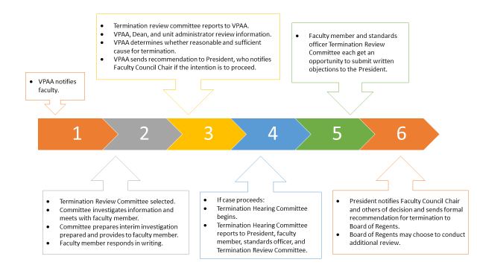
McCann asked for questions. McFarlane asked, regarding the past Faculty Council chair person who is picked at random, does the recommendation cover any conflicts of interest if they are from the same college? McCann stated there was a place in the policy that covers conflicts of interest. This would definitely be one of them. It was asked how long step 1 took. McCann stated she has not personally been involved in a termination, so she does not know. It was then asked when why does the process need to be changed. McCann answered that there has been discussion about how administrators are avoiding this procedure even when it is warranted, because it is such a long process. Gary Clark stated that this has been a lengthy process, usually 3 months up front. Clark counted 9 steps that someone has to make a decision to proceed with the inquiry. The recommendation does not gut the entire process - it just shortens the interim steps. McCann stated that the investigating committee is supposed to talk to the department, unit administrator, faculty member and members of the unit.
DeSilva asked if there was any more discussion? Seeing none, moved to a vote. The motion passed.

FACULTY COMMITTEE
2017-18 Annual Report
May 8, 2018

Members:
Robert Emerson, Chair (Civil and Environmental Engineering)
Mindy McCann, Interim Chair (Statistics)
Cindy Melancon (Psychology)
Gina Peek (Design, Housing and Merchandising)
Justin Talley (Entomology and Plant Pathology)
Camille DeYong (Industrial Engineering & Management)
Nicholas Materer (Chemistry)
Holly Karibo (History)
Pamela Lovern, Faculty Council Secretary, Ex Officio (Physiological Sciences)
Barbara Miller (Emeriti Association)

Faculty Committee completed work on the following documents:

19-02-01-Verification of Teaching Faculty Qualifications.
- Passed February 12, 2019
- A new “Policy for Verification of Teaching Faculty Qualifications” was developed to meet requirements for accreditation by the Higher Learning Commission.
- The policy was originally developed by Brenda Masters.
- The policy was reviewed and edited by the Faculty Committee.
- The policy sets up the process for documenting teaching faculty qualifications by either academic credentials or approved tested experience exceptions.
Appendix C: General Termination Procedures
- Suggested changing the current procedure which involved three investigations by different groups to one investigation with representation from all three original groups
- This streamlines the process and reduces the obvious redundancy in the current process, while still allowing for representation from all of the previous investigating bodies

Other activities:

Upon the request of the Provost, Faculty Committee is currently reviewing 3 dossiers for reappointment, promotion and tenure.

Ongoing Activities:

The Faculty Committee has many topics under consideration/review. The primary topics for future activity include:

- Reviewing the faculty termination process and how cumulative review procedures fit into it.
- Evaluating if non-tenure track teaching faculty should be eligible for a Regents Distinguished Teaching Award. Currently the award can only be awarded to tenure track faculty. Consideration is being given to either including non-tenure track faculty in with tenure track faculty for the award or having a new award for only non-tenure track faculty.
- Evaluating if/how community engagement can be used in the RPT process.

- Long-Range Planning and Information Technology: Eric Rebek – Year End Report
Long-Range Planning and Information Technology Committee – Year End Report 2018-19
LONG RANGE PLANNING AND INFORMATION TECHNOLOGY COMMITTEE

Faculty Council Members: Eric Rebek (Chair, Entomology and Plant Pathology), Mindy McCann (Statistics, Faculty Council Vice Chair), Subhash Kak (Electrical and Computer Engineering), Christopher Crick (Computer Science)
General Faculty Members: Matt Bowler (Management), John Kirkpatrick (Emeriti Representative), Shane Lyon (Veterinary Teaching Hospital), Ki Cole (Educational Studies), and Kevin Dyke (Library)

The committee made the following recommendations:

- OSU Intellectual Property and Copyright Policy. Following two years of careful review by the committee in collaboration with Research Committee, Faculty Council approved the recommendation on October 9, 2018, pending further review of the policy by the Office of Academic Affairs and the Graduate College for consistency with existing policies and procedures. On February 12, 2019, Drs. Sandefur and Sewell reported that the policy was accepted and would be immediately effective upon approval by the OSU/A&M Board of Regents.
- Support for One Classroom Response (“Clicker”) System. In collaboration with Student Affairs and Learning Resources Committee, the committee recommended that OSU provide support for only one clicker system. Faculty Council moved to approve the recommendation on March 12, 2019. Dr. Chris Ormsbee and ITLE will be conducting a thorough evaluation of existing clicker systems before deciding on a system to support for instruction throughout the OSU/A&M system.

Other activities:

- Eric Rebek met with Scott Frazier and the Campus Facilities, Safety, and Security Committee on April 5, 2019 to discuss ongoing efforts to enhance security on campus. Both committees will work together in the coming academic year to obtain usage data for Orange Shield and information about how security cameras and lighting can be used effectively on campus, especially in parking lots.
- Members of the committee have expressed an interest in addressing food insecurity issues for OSU students. Faculty Council, Student Government Association, Our Daily Bread, and other entities are collaborating to raise awareness and provide resources for affected students.

Respectfully submitted by:
Eric Rebek, Chair, Long-Range Planning and Information Technology Committee
May 8, 2019
- Research: Dianne McFarlane – Year End Report

Faculty Council Research Committee: End of year report

Committee members: Dianne McFarlane (Chair), Franklin Champlin, Nurhan Dunford, Suhbash Kak, Ajay Kumar, David Lewis, Edralin Lucas, Tracy Quan

The research committee started off the year working with the undergraduate research office to streamline the award process for the transcript designation, “Undergraduate Research Scholar” and to help increase awareness of the program. The committee met with Associate Dean Brenda Smith and members of the Strategic Group on Research Excellence (SCORE) to discuss the data they have gathered regarding obstacles to research at OSU and to identify areas where faculty council involvement would be appropriate. The committee also met with Vice President Sewell, Associate Vice President Van Den Bussche and Assistant Vice President for Compliance Dawn Underwood regarding research priorities for the university. An outcome of this meeting was that committee members were invited to attend a presentation by a research marketing group, The Conversation. Participation in this marketing platform is being considered by research administration to help address the poor visibility of research at Oklahoma State University. Finally the committee reviewed proposed revisions to Oklahoma State University Policy and Procedures 4-0125, Complaints of Research Misconduct. These proposed revisions, submitted to Faculty Council by Vice President for Research Ken Sewell, were suggested to better align OSU policy with that of the Public Health Services and National Science Foundation.
- Retirement & Fringe Benefits: Griffin Pivateau – Year End Report

Retirement and Fringe Benefits Committee Year End report

Members: Griffin Pivateau, Chair, Karen Neurohr, Benjamin Bindewald, Cheryl Giddens, Mark Thai, Deb VanOverbeke, and Robert Wettemen.

In 2018-19, the OSU Retirement and Fringe Benefits Committee focused on issues of transparency and communication. In initial meetings, the committee determined that the greatest challenge for faculty was understanding the many changes that have taken place in the retirement system since 2011. In the fall, OSU Retirement Manager Amy Hoy provided the committee with a comprehensive presentation on the state of the two retirement systems in place at OSU, the OTRS pension plan and the TIAA Alternative Retirement Plan.

The committee invited Ms. Hoy to present to the Faculty Council as a whole. The committee worked together to identify the key issues that Ms. Hoy should cover in her Faculty Council report. The committee chair met with Ms. Hoy regarding the substance of those issues. Unfortunately, due to unexpected circumstances, Ms. Hoy was unable to speak to the Council at the April meeting. She has, however, promised to appear in fall 2019 for her report.

In the next year, the Retirement and Fringe Benefits committee intends to continue its efforts to ensure the OSU faculty has a broader understanding of retirement possibilities and options.
i. Rules and Procedures: Mindy McCann for Pamela Lovern – Year End Report
RULES & PROCEDURES COMMITTEE
2018-19 Annual Report
May 10, 2019

Members:
Pamela Lovern, Rules & Procedures Committee Chair & Secretary, Faculty Council (Physiological Sciences)
Rene Hurst (OSU-OKC)
Subhash Kak (Electrical & Computer Engineering)
Jam Khojasteh (OSU-Tulsa)

This year, the Rules & Procedures Committee oversaw the election of new Faculty Council representatives and a new Faculty Council Vice Chair. Election results are below:

A&S: Tyrell Conway (1 year term)
Cristina Gonzalez (2 year term)
Toby Nelson, Cindy Melancon, and Matt Lovern (3 year terms)
CASNR: Bruce Dunn
CEAT: Tieming Liu
CoEHA: Ki Cole
CHS: Sarah Hall
SSB: Harounan Kazianga
OSU-OKC: Anthony Smith

This year, there was a tie for the Vice Chair position. Jon Ramsey and Gina Peek each received equal number of votes from the general faculty. According to the Bylaws of the General Faculty, the process for breaking a tie vote is to draw lots to select the winner. This was done by the Faculty Council officers. Faculty Council Chair Udaya DeSilva then formally challenged the election result as described in the Bylaws of the General Faculty. This allowed Faculty Council to proceed to a secret vote of Faculty Council members to determine the winner of the Vice Chair election. A secret ballot was conducted at the April 9, 2019 Faculty Council meeting. Gina Peek received the majority of the votes in this ballot. She will therefore take up the office of Vice Chair of Faculty Council for 2019-20. The officers of Faculty Council recommend that the current election procedure described in the Bylaws of the General Faculty be assessed by Faculty Council during the next academic year and updated/revised as necessary.

The Rules & Procedures committee, in conjunction with the officers of Faculty Council, also oversees the appointment of faculty members to the Standing Committees of Faculty Council, as well as the appointment of faculty to various University-level committees. To assess faculty interest in serving on these various committees, the Committee Preference Survey was distributed to OSU faculty on April 17, 2019 with a closing date of April 29, 2019. The results of the survey will be analyzed during the week of May 13, 2019 and used as a guideline for assigning members to each committee.

Respectfully submitted,
Pamela Lovern, Rules & Procedures Committee chair

- Student Affairs and Learning Resources: Gina Peek – Year End Report

OSU Faculty Council
Student Affairs and Learning Resources

Chair – Gina Peek, Associate Professor, Design, Housing and Merchandising
Members: Shaoqian Zhang, Rebecca Sheehan, Steve Wanger, Adam Molnar, Adriana Petrova, Kent Sampson, Jessica Schnaiter-Brasche, Matti Betts.

May 10, 2019

Recommendation SALR made the following recommendation to Faculty Council on February 12, 2019:
- 19-02-01-SALR: Guidelines for Reducing Textbook Costs. The recommendation was presented to Faculty Council. Faculty Council Chair asked for discussion. Seeing none moved to a vote. Motion passed.

Ongoing effort SALR will continue to examine textbook costs.
- SALR actively pursued the request made by Provost Sandefur to begin a dialogue with Faculty Council about how we can help reduce costs to students, particularly with regards to textbooks and fees. A University Wide committee is being formed to help address the issue.
SALR will join the University Wide discussion of food insecurity in 2019-2020.

- Academic Standards and Policies: Jon Ramsey – Update/Year End Report

Recommendation: Reinstatement of Undergraduate Students after Academic
Suspension 2-0802 Academic Affairs*

Ramsey discussed the recommendation which was attached to the agenda.

DeSilva asked for questions/discussion. Seeing none moved to a vote. Motion passed.

Faculty Council
Academic Standards and Policy Final Report

Chair-Jon Ramsey, Associate Professor Agricultural Education, Communications and Leadership
Members: Scott Frazier, Rebecca Sheehan, Angie Piehl, Karin Schestokat, Tom Wikle, Carol Jones, Kathryn Castle, Mario Borunda, Ayo Ibukun

Committee Actions:

The AS&P committee met monthly throughout the academic year. Representatives or the chair represented Faculty Council on the following Academic Affairs Committees (Retroactive Drop/Withdrawal Committee, Academic Reprieve & Renewal Review Committee, and the Grade Appeals Board)

In addition to committee representation, AS&P submitted two recommendations to faculty council for approval.

- OSU Academic Regulation 4.4, 4.6, and 7.2 Credit by Exam Application to Undergraduate Degree Requirements
- Reinstatement of Undergraduate Students After Academic Suspension 2-0802 ACADEMIC AFFAIRS

AS&P in cooperation with the Athletics Committee is working on an attendance policy that better defines excused absences.

Report submitted, May 7, 2019

Old Business – None
New Business – Introduction of newly elected Council members.

DeSilva introduced the newly elected Faculty Council members in attendance at today’s meeting.

DeSilva handed out certificates to the retiring Faculty Council members.

The meeting adjourned at 4:04 p.m. The next regular meeting of the Faculty Council is Tuesday, August 20, 2019 at 3:00 p.m. in the Sequoyah Room, Student Union.

Respectfully submitted,
Pamela Lovern, Secretary

